Earthport Merchant API Reference .NET Client - Internal Technical Documentation

Author: | Akshay Luther / Alex Lee
Date Created: | Nov 3, 2008
Last Updated: | Feb 26, 2010
Version: | 1.1
Status: | Reviewed

Contents

Earthport Merchant API Reference .NET Client - Internal Technical Documentation 1
Contents 2
Purpose 3
Earthport Merchant API Overview 4
Versioning 4
Security 5
Error Handling 5
What is the .NET Reference Client? 6
WCF Client 6
WSE Client 6
Design Goals 6
Requirements 7
Requirements for the WCF Client 7
Requirements for the WSE Client 7
Solution Overview 8
Client Implementation Details 9
MerchantAPI Project 9
SampleClient Project 13
MerchantAPI.Test 13
Exception Handling 16
Common Exceptions (WCF Client) 16
Common Exceptions (WSE Client) 16
Building with Nant 18
Nant Introduction 18
Nant Process Outline 18
Executing the Nant Script 18
Miscellaneous Notes 19
SSL In Test Environment 19
Timestamp in SOAP Response 19
Packaging for Customer Use 20

Purpose

This is the internal technical documentation for the .NET Reference Client which has been developed to prescribe to merchants the recommended approach to integrate with the Earthport Mechant API web service using .NET. It is targeted at those who would like to gain a technical understanding of how the client has been implemented for the purpose of developing it further, supporting it, providing advice to Earthport’s clients using .NET etc.

Earthport Merchant API Overview

The Earthport Merchant API enables integration of merchant systems with Earthport. The API is exposed as a SOAP web service and is defined using a combination of WSDL and XSD.

In essence, the WSDL specifies a single web service operation called ‘SubmitDocument’ with an input of ‘Request’ and an output of ‘Response’. The definitions of both ‘Request’ and ‘Response’ contain an XML Schema “<any/>” element. In other words, the WSDL simply states that it will accept any valid XML as input and return valid XML as output. Thus, the WSDL itself does not define the structure of the ‘Request’ and ‘Response’ and hence on its own is loosely-typed.

However, a set of XML Schemas defined separately dictates the format of the request / response elements. Each XSD file defines the ‘Request’ for a particular API function along with the corresponding ‘Response’. The request schema can be used to validate the request XML for a particular service on the client-side prior to it being sent to the server. Hence as a whole, the web service is strongly typed.

Additionally, the schemas can be used to generate classes native to the client implementation by leveraging the client platform’s ‘xsd-to-class binding’ tools which can then be used to a) convert request objects to XML and response XML back to response objects, allowing seamless integration with the development platform used on the client.

This approach (a single generic web service operation defined using WSDL along with request / response XSD defined separately) has several advantages over a more traditional set of strongly-typed web services defined entirely within a single WSDL document:

- Allows versioning of individual functions separately
- A single web service instance supports clients using several versions simultaneously
- Client code does not break when newer versions of functions are released (and they can choose when to upgrade)
- When a new version of a function is released, only that function’s class needs to be generated from XSD, coded against and regression tested
- Easily extensible interface (new functions can be added easily without modifying the WSDL interface)

Versioning

Each service is versioned separately. The request schema definition for a particular service includes a ‘fixed’, ‘required’ version attribute on the root element:

<xsd:attribute name="version" type="xsd:decimal" use="required" fixed="1.0"/>

This example specifies that the root element must contain a version attribute and that it must have the exact value “1.0”. This allows the version number to be automatically specified in the request document (by leveraging ‘class-to-xsd tooling’) and hence be transparent to the client application. On the server-side, this attribute can be easily read and the appropriate response returned.

Security

The web service is secured using a combination of transport level security (SSL over
HTTP) and WS-Security.

Privacy & Integrity

Privacy and integrity are assured through the use of SSL.

Authenticity

Server authenticity is assured through the use of SSL. Client authenticity is assured through the use of WS-Security, specifically a Username Token in the SOAP message header in which a merchant username and password as supplied.

Error Handling

As part of the ‘Response’ definition in the service WSDL, an ‘ack’ value is returned,
which is either ‘success’ or ‘failure’. If it is ‘success’, the corresponding response
document is returned. However, if it is ‘failure’ a document of type ‘ErrorResponseType’ is returned, which can be represented as a native error on the client platform (.e.g a .NET exception).

What is the .NET Reference Client?

The Reference .NET Client shows how to use .NET to integrate with the Earthport Merchant API web service. There are two implementations of the client, both written in C#:

WCF Client
The WCFClient is a Microsoft Visual Studio 2008 solution targeting .NET Framework 3.5. It uses the in-built Windows Communication Foundation (WCF) infrastructure to communicate with the web service.

WSE Client
The WSEClient is a Microsoft Visual Studio 2005 solution targeting .NET Framework 2.0. It uses in-built support for web services in conjunction with Microsoft Web Service Enhancements (WSE) 3.0 to communicate with the web service.

Each provides a native .NET class (ServiceProxy) that abstracts the lower-level implementation details of communicating with this web service. Also included is a sample application that demonstrates how ServiceProxy can be used to write a .NET client application.

Both implementations are consistent in terms of overall design and naming; the main difference is the underlying technology used for communication with the web service. The WCF Client also uses some new features of C# 3.0. Unless otherwise noted, any discussion applies to both implementations.

Design Goals

The ServiceProxy class was designed with the following goals in mind:

- Simplicity: It should be as easy to use and abstract as much of the plumbing as possible
- Reuse of Service Metadata: Corresponding .NET classes should be automatically generated from the WSDL and XSDs types.
- Use of Best Practices: It should incorporate best practices and serve as a model for concrete implementations.

Requirements

Requirements for the WCF Client

- Visual Studio 2008
All code is contained in a Visual Studio 2008 solution, including the client library, sample application and tests.

- NUnit 2.4.8
The tests are written for NUnit. NUnit can be downloaded from:
http://www.nunit.org/index.php?p=download

Requirements for the WSE Client

- Visual Studio 2005
All code is contained in a Visual Studio 2005 solution, including the client library, sample application and tests.

- Web Services Enhancements (WSE) 3.0 for Microsoft .NET Redistributable Runtime
WSE 3.0 provides support for WS-Security and is available at:
http://www.microsoft.com/downloads/details.aspx?FamilyID=9e59c3fb-e7bc-4d91-908e-411a8d329f3d&displaylang=en

- NUnit 2.4.8
The tests are written for NUnit. NUnit can be downloaded from:
http://www.nunit.org/index.php?p=download

Solution Overview

- Native .NET classes are automatically generated from the service XSDs. These classes are used by the client application to specify a service request and process a response
- A .NET proxy (‘MerchantAPIService’) is automatically generated from the service WSDL. It provides a ‘SubmitDocument’ method which takes a request ‘XmlElement’ as input, uses SOAP to invoke the web service and returns a response ‘XmlElement’.
- A ‘ServiceProxy’ class sits between the client application and the autogenerated .NET proxy and is responsible for:
  - Serializaton of a request object to request XML
  - Validation of the serialized XML prior to invoking the service
  - Deserialization of response XML to an response object
  - Ensuring that a properly constructed WS-Security Username Token is supplied as part of the SOAP request

The following sequence diagram shows an overview of the interaction of these subsystems for a “CreateAccount” operation.

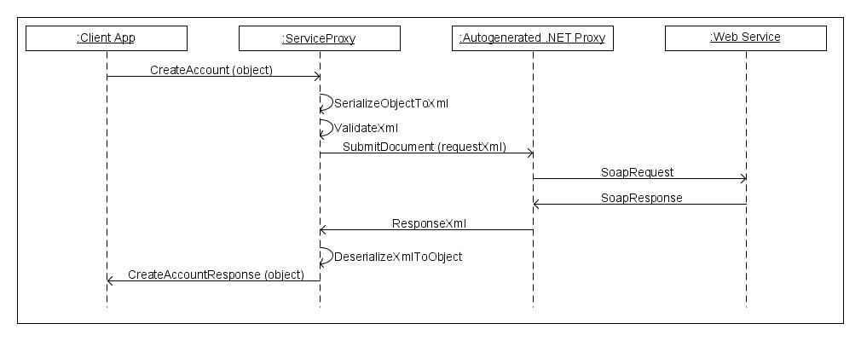

Client Implementation Details

The Visual Studio solution is structured as follows. There are three projects in solution. The following screenshot of the WCF Client Solution Explorer shows the contents of each project.

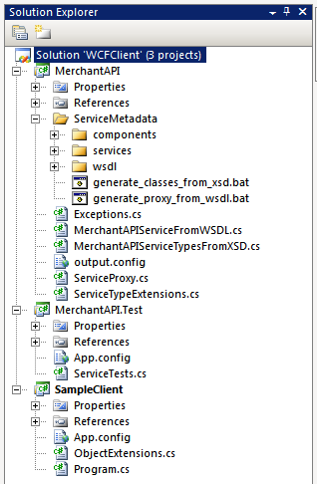

MerchantAPI Project

The MerchantAPI project’s output is a .NET DLL that abstracts the details of communicating with the Earthport API and is referenced by a client application. The ServiceMetadata folder contains the service metadata published as part of the Earthport web service interface (wsdl, services XSDs and components XSDs). Other files:

- MerchantAPIServiceFromWSDL.cs: contains an automatically generated proxy used to communicate with the web service.
- MerchantAPIServiceTypesFromXSD.cs: contains automatically generated .NET classes from the XSDs in services folder and the XSDs in the components folder that they depend on.
- Exceptions.cs: defines a custom exception ServiceErrorException which wraps the error response from the web service
- ServiceProxy.cs: defines the service proxy, the main class used by clients to communicate with the web service. Responsible for marshalling requests from objects to XML, validated the serialized XML, calling the web service and unmarshalling the response.
- ServiceTypeExtensions.cs: Helper extension methods. (There is no equivalent file in the WSE Client – the equivalent helper methods are contained in ServiceProxy.cs)

Generating ‘MerchantAPIServiceFromWSDL.cs’ (WCF Client)
A batch file called ‘generate_proxy_from_wsdl.bat’ exists in the ‘ServiceMetadata’ folder. This is used to generate a proxy class for communicating with the web service. The .NET ServiceModel Metadata Utility Tool ‘svcutil.exe’ tool is used, which is documented here:
http://msdn.microsoft.com/en-us/library/aa347733.aspx

Note that you must either have ‘svcutil.exe’ in your path when running the batch file, or run it from the Visual Studio 2008 Command Prompt (Start -> Programs -> Microsoft Visual Studio 2008 -> Visual Studio Tools -> Visual Studio 2008 Command Prompt)

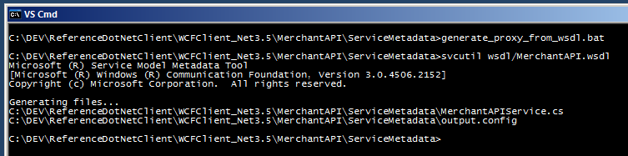

Two files are generated:
- ‘MerchantAPIService.cs’, containing a ‘MerchantAPIClient’ class which is used by the ServiceProxy to communicate with the web service
- ‘output.config’, although is not used directly by the project, contains the ‘System.ServiceModel’ configuration to be applied to the final client application (app.config for Windows applications or web.config for web applications) This file should be moved to the project root to replace the existing file with the same name after the following changes have been made:
  - Security mode should be changed from ‘Transport’ to ‘TransportWithMessageCredential’
    - <security mode="TransportWithMessageCredential">
  - The transport ‘clientCredentialType’ should be changed from ‘None’ to ‘Basic’
    - <transport clientCredentialType="Basic" ..

Generating ‘MerchantAPIServiceFromWSDL.cs’ (WSE Client)

A batch file called ‘generate_proxy_from_wsdl.bat’ exists in the ‘ServiceMetadata’ folder. This is used to generate a proxy class for communicating with the web service. The .NET Web Services Description Language Tool (‘wsdl.exe’) is used, which is documented here:
http://msdn.microsoft.com/en-us/library/7h3ystb6.aspx

Note that you must either have ‘wsdl.exe’ in your path when running the batch file, or run it from the Visual Studio 2005 Command Prompt (Start -> Programs -> Microsoft Visual Studio 2005 -> Visual Studio Tools -> Visual Studio 2005 Command Prompt)

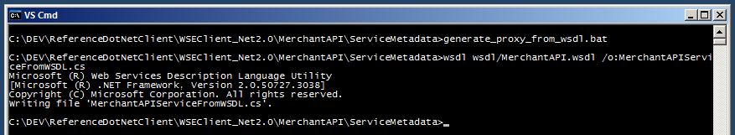

A file called ‘MerchantAPIServiceFromWSDL.cs’ is generated, containing a ‘MerchantAPIService’ class. In the generated code, this class derives from ‘System.Web.Services.Protocols.SoapHttpClientProtocol’ which does not support WS-Security functionality. The ‘MerchantAPIService’ class must therefore be derived from the ‘Microsoft.Web.Services3.WebServicesClientProtocol’ class which is made available as part of WSE 3.0.

In order to do this, in the generated file, replace the string ‘System.Web.Services.Protocols.SoapHttpClientProtocol’ with ‘Microsoft.Web.Services3.WebServicesClientProtocol’.

Finally, the file should be moved to the project root to replace the existing file with the same name.

Generating ‘MerchantAPIServiceTypesFromXSD.cs’

A batch file called ‘generate_classes_from_xsd.bat’ exists in the ‘ServiceMetadata’ folder. This can be used to generate .NET classes from the relevant XSD files. The .NET XML Schema Definition Tool (‘xsd.exe’) is used, which is documented here:
http://msdn.microsoft.com/en-us/library/x6c1kb0s.aspx

Note that you must either have ‘xsd.exe’ in your path when running the batch file, or run it from the Visual Studio 2005/8 Command Prompt (Start -> Programs -> Microsoft Visual Studio 2005/8 -> Visual Studio Tools -> Visual Studio 2005/8 Command Prompt)

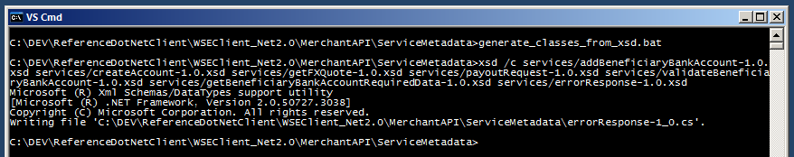

The generated file (‘errorResponse-1.0.cs’) must be renamed to ‘MerchantAPIServiceTypesFromXSD.cs’ and moved to the project root to replace the existing file of the same name. Note that if additional XSDs are added to the API, the batch file will need to be modified to reflect this.

Embedding the schemas

The set of request schemas is required to perform validation of request XML prior to
invoking the web service and need to be shipped with the MerchantAPI assembly. In
order to make deployment easier, the schemas are embedded into the MerchantAPI assembly so that individual files do not have to be deployed with the assembly and the code does not have to use filesystem paths to access the schemas.

To embed the schemas, each XSD file’s ‘Build Action’ needs to be set to ‘Embedded Resource’. This is shown in the screenshot below.

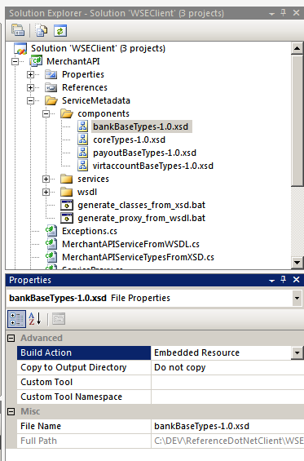

SampleClient Project

This is a sample console application that demonstrates the use of the Earthport Merchant API web services via the ServiceProxy. It also shows how data returned by the GetBeneficiaryAccountRequiredData service can be used to
- generate UI elements on-the-fly
- set properties dynamically on a BeneficiaryAccount object using reflection

MerchantAPI.Test

This is a class library project containing tests written for NUnit. To run the tests, NUnit must be installed. The following screenshot shows how the ‘MerchantAPI.Test’ project is configured (right-click the ‘MerchantAPI.Test’ project in the Solution Explorer and select “Properties”) to start NUnit and load the DLL when the project is run.

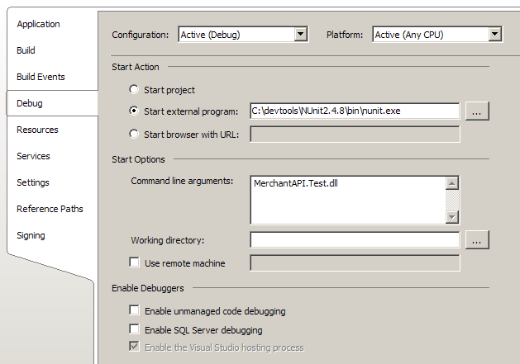

The path to the NUnit executable is specified in the ‘Start external program’ field, and the name of the output assembly (‘MerchantAPI.Test.dll’) is specified in the ‘Command line arguments’ field.

In order to run the tests, right-click the ‘MerchantAPI.Test’ project in the Solution Explorer and select ‘Set as Startup Project’. Now when the solution is started, NUnit starts up with the assembly loaded:

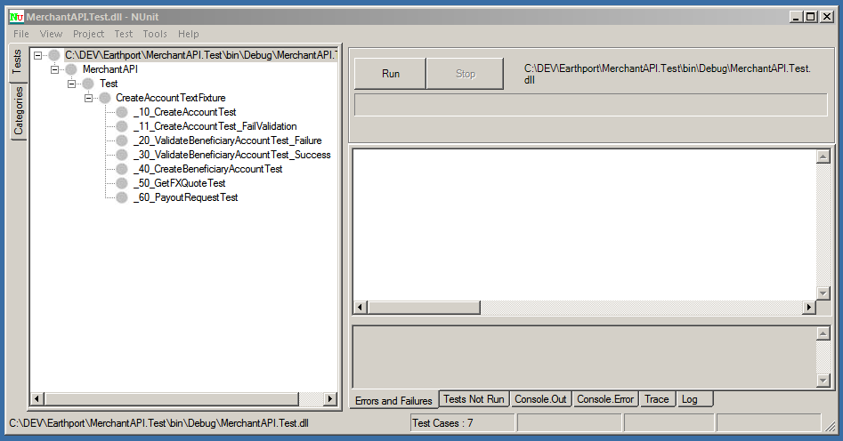

The tests can now be run by clicking the ‘Run’ button.

Exception Handling

Several types of exceptions can be thrown when a method on the ServiceProxy is called. The client application should handle each of these exceptions in addition to the generic System.Exception.

Common Exceptions (WCF Client)

Exception | Notes
System.Xml.Schema.XmlSchemaValidationException | Thrown when the request XML cannot be validated against its corresponding schema. e.g. a 2-character currency value is supplied, but the schema specifies that it must be exactly 3 characters long
Earthport.MerchantAPI.ServiceErrorException | Thrown when the service responds with an ‘ack’ value of ‘failure’ e.g. the supplied subMerchant does not exist when attempting to create an account.  The ‘ErrorResponse’ property contains an error code, unique error ID, short message, long message and optionally a collection of failures (key-value pairs)
System.ServiceModel.Security.SecurityAccessDeniedException | Thrown when the security credentials (username and password) are not valid.
System.ServiceModel.EndpointNotFoundException | Thrown when the service cannot be reached (e.g. due to a network issue)

Common Exceptions (WSE Client)

Exception | Notes
System.Xml.Schema.XmlSchemaValidationException | Thrown when the request XML cannot be validated against its corresponding schema. e.g. a 2-character currency value is supplied, but the schema specifies that it must be exactly 3 characters long
Earthport.MerchantAPI.ServiceErrorException | Thrown when the service responds with an ‘ack’ value of ‘failure’ e.g. the supplied subMerchant does not exist when attempting to create an account.  The ‘ErrorResponse’ property contains an error code, unique error ID, short message, long message and optionally a collection of failures (key-value pairs)
System.Web.Services.Protocols.SoapException | Thrown when the web service returns a SOAP Fault. e.g. login failure
System.Net.WebException | Thrown when a network error occurs connecting to the web service e.g. incorrect URL supplied

Building with Nant

Nant Introduction
NAnt is a free .NET build tool based on Ant for Java. With NAnt we can automate a lot of the processes required to build up the sample clients for both WSE2.0 and WCF3.5 versions.

For a complete guide to NAnt including good documentation about all available commands, see [http://nant.sourceforge.net]

The Nant scripts are currently executed within a CruiseControl.NET instance which is running on vmprof1. These execute against the CIE environment every hour and are designed to fail if the definitions for any existing services are altered.

Nant Process Outline
The current Nant script for WCF3.5 and WSE 2.0 performs the following tasks during a default build process:
- Deletes all previous artifacts
- Builds the Merchant API dll library file using the xsds and wsdl located within MerchantAPI/ServiceMetadata.
- Builds the NUnit Service Test client against a specified environment provided within the Nant init target. The Nant init target also specified a username and password to use.
- Builds the sample client against a specified environment provided within the Nant init target.
- Executes the set of NUnit tests located in the newly built MerchantAPI.Test.dll against the specified environment.

Executing the Nant Script
Steps on how to build using the Nant script can be found within the document MerchantAPI_Design_and_XSD_Guidelines.rtf .

Miscellaneous Notes

SSL In Test Environment

For testing purposes, the WSE Client uses HTTP to access the web service. The WCF Client on the other hand uses SSL over HTTP since WCF does not allow the transmission of a plaintext password over an unsecured transport. However, since there are issues with the SSL certificate installed on the test server (specifically, the common name does not match the host name and the certificate is self-signed), the host is not trusted and trust exceptions are thrown when attempting to communicate with the web service. To bypass these exceptions the validation of the certificate has to be overridden. This is done by using the ‘ServerCertificateValidationCallback’ property of ‘ServicePointManager’.

ServicePointManager.ServerCertificateValidationCallback += new RemoteCertificateValidationCallback(OverrideCertificateValidation);

The callback implementation can then ignore any SSL policy errors:

private bool OverrideCertificateValidation(object sender, X509Certificate cert, X509Chain chain, SslPolicyErrors error)
{
return true;
}

However, this must not be done in a production environment and code provided to customers should have these bits of code removed.

Note that these blocks of code have been surrounded with #if DEBUG and #endif directives as an additional safeguard against it being included in a release build.

Timestamp in SOAP Response

The binding used in the WCF Client in the out-of-the-box configuration expects to receive a timestamp in the SOAP response. Because the web service does include a timestamp in the response, the binding needs to be modified to not expect a timestamp.

BindingElementCollection elements = _client.Endpoint.Binding.CreateBindingElements();
elements.Find<SecurityBindingElement>().IncludeTimestamp = false;
_client.Endpoint.Binding = new CustomBinding(elements);

Packaging for Customer Use

When the sample client is packaged and distributed to the customer, the WSDL must have a public HTTPS URL. Currently, this is not the case.

